A Role for Pesso Boyden System Psychomotor in Healing the Wounds of Compulsory Heterosexuality and Policed Gender Roles

(Article based on workshop at the Prague International PBSP Conference, 2019)

Gus Kaufman, Jr., Ph.D., Senior PBSP Trainer, Atlanta, Georgia, USA
Abstract:
PBSP has been part of a psychosocial system that has damaged people who don’t identify as stereotypically heterosexual and/or don’t fit stereotypical gender roles. To be part of the solution, we need to expand who can role play ideal parents. Secondly, we need to allow and validate each person’s unique integration of polarities around what is called masculine and feminine. Finally, we need to create more openness and validation around non-heterosexual attractions and relationships.

(Thanks to Matt Fried, Ph.D., PBSP Trainer for help revising this paper.)

People who call themselves heterosexual often don’t know how fiercely they have been indoctrinated in a way of life that oppresses others and themselves. This is just like how people who call themselves white have learned to be blind to how we are part of oppressing all the non-whites in the world. We in PBSP with our notions of the possibility sphere, of honoring and validating all of who a person is, can become part of the solution, not part of the problem.

Because of how global our gender indoctrination is, it’s hard to show you what you don’t know and it’s hard to talk about it. When I did this workshop, I started with an exercise which made no sense to some people, because they don’t know how indoctrinated they are in policed gender roles. I told a joke,
“Why do some gay men talk with their hands like this?” (I demonstrated by waving my hands around at mid-body level.)
The answer:
“Because sometimes there’s not room to talk like this! (I threw my arms up over my head, palms open to the sky.)

I think some people in the workshop didn’t get it. They didn’t have conscious knowledge that boys and men are socialized to inhibit our body movements to what is considered masculine, and that talking with your hands and especially throwing your hands above your head is considered flamboyant, over-the-top, hysterical, too emotional. Some brave gay men defy this stereotype and for that, they are stigmatized… sometimes to the point where they are murdered… or kill themselves.

Then I told two stories that also fell flat. The first was about a participant in a PBSP workshop I led in Basel 30 years ago, a young male medical student. He did some anger work around his upbringing (we used to pound pillows back then!) and the next day came in with a cast on his arm. He had broken a tendon in his thumb but said nothing to us when it happened. I was stunned that a person could break a tendon and not say anything about it. To me, this was an obvious example of how narrowed his range of emotional awareness and expression was by policed gender roles.

The second example was from my childhood. My mother called to me as I ran across the yard, “Turn your hands around (meaning so they didn’t face forward).” This is as an example of shaming a male child out of being vulnerable and free, because openness was seen as feminine and feminine was the worst thing a boy could be. My mother, to protect me from bullying, was reinforcing policed gender roles, helping suppress my free self-expression.

What do those examples have to do with PBSP? When we insist that ideal parents have to be a male and a female, when we avoid issues of sexual/affectional desire--who we are attracted to and want to bond and partner with, how we express ourselves and don’t based on rigid gender roles, then we in PBSP are part of the apparatus of oppression.

What happens when we don’t integrate the polarities of our lives?
Al Pesso was keenly aware of the polarities of masculinity and femininity, receptivity and putting out, power and vulnerability, input and output. He knew, but did not always explicitly spell out, that what cannot be owned is projected and denied. If you don’t own a part of yourself it becomes a symptom. We end up with personal symptoms, e.g., the tight jaw and teeth-grinding of the male who is holding so much back, and societal symptoms, e.g. males’ refusals to acknowledge vulnerability. That refusal costs everyone.

In PBSP we have reinforced traditional sex roles when we insisted the road to healing for everyone was an ideal mother, played by a woman, and an ideal father, played by a male. That works fine for many people. But it deepens the alienation of those who don’t feel like it fits for them.

We need to offer clients options, a broadened possibility sphere. We can say, “what would be an ideal reversal for you? Who would you like to play ideal parents, ideal family, ideal people who would have raised you?”

Secondly, PBSP has been passive, has not spoken out on same-gender attraction and affiliation.
Sexual and affectional desire, choice and bonding are enormously important parts of who we are as living creatures. To counter the oppression people have suffered under, we need to have ideal parents, ideal religious and social institutions that explicitly say ‘We affirm and celebrate you having desire and wanting to be with whomever you want, so long as they are also free to choose.’

Thirdly, we need to explicitly give the message that you can be you in the way that fits for you. You can use pronouns that reflect how you see yourself and your ideal figures (and the therapist and fellow group members) will follow your lead. This is basic respect. We are not prescribers or enforcers of the one-right-way to resolve the polarity of masculine and feminine.

All this needs to happen in one-to-one therapy, in group therapy and in training groups. We need to go from people hiding who they are to us making a place for and celebrating them. Trainers and trainees should not have to keep their sexual, affectional and familial lives ‘private,’ ‘nobody else’s business.’

We are at a societal crossroads where majorities are being forced to realize that leaving the status quo in place is oppressive. Keeping silent is not a moral choice. This is a PBSP issue too—as Al Pesso noted, “The roots of justice are in the body.” What I take that to mean is that we are profoundly oriented toward justice.

What are the implications of that for gender and sexuality? I have been talking about injustice in society, mirrored in the theory and practice of PBSP. Al Pesso speaks of ‘See/Do’. What that means here is if we see an injustice we are pushed by our nature to do something about it—to make it right. (In his notion of ‘holes in roles’ and ‘the Messiah complex’ he talked about when the child sees an unmet need, an injustice in the family or society, they feel pulled to fix it.)

As you will see, in this work I continually mention gender roles and sexual orientation—desire and choice. That’s because these are the areas we have been not allowed to be our full selves in all our complexity.

The concept of compulsory heterosexuality comes from “Compulsory Heterosexuality and Lesbian Existence" a 1980 essay by Adrienne Rich, (also published in her 1986 book Blood, Bread, and Poetry: Selected Prose 1979-1985). It is the recognition that in our society everyone has been expected to be heterosexual and had better force themselves into it if they are not, or be silent, ‘closeted.’

The idea of policed gender roles I took from Marilyn Frye, who in The Politics of Reality, 1983 wrote of the methods and costs (billions, plus untold human suffering) of enforcing this regime. It is the notion that ‘this is a man’ and ‘this is a woman’ and you better make yourself fit. Go to the gym, wear your hair a certain way, hold and move yourself in certain ways and not in others, get surgery if need be to fit, and for males, be in charge, don’t cry, for females, always smile, don’t be aggressive, and on and on.

Those who step outside those patterns risk rejection, shaming, even death. “We were socialized to respect shame and silence over our own voices.” Nicole Dennis-Benn, Jamaican born U.S. author. The domains of gender expression and sexual/affectional orientation and expression are allied and interwoven.

In PBSP we diagram the repression this way—parts that are allowed to be expressed and then met/blessed/countershaped vs. parts that have no place and have to be denied and then are forced underground, appearing as symptoms. 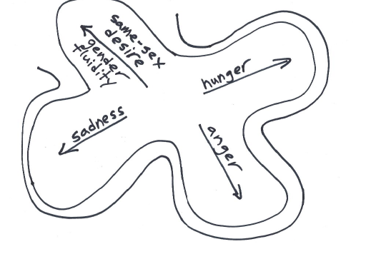

One of the ways PBSP offers healing is through the witness feeding the pilot information about formerly disallowed affects that the person is somehow manifesting. This is true for males, females, transgender people and people with a fluid sexual identity.

For women, what are the disallowed affects? What is the ‘Act Like a Woman Box’? And what is said and done to girls and women to keep them in the box? Anger and aggression are among the disallowed affects for which women are stigmatized. They are kept in line by the fear of being called ‘bitch’, ‘shrew’, ‘harridan’, ‘shrill’, ‘strident’. Jackie Zilbach, MD, PBSP ally and one of my mentors, co-authored with three other women psychiatrists/psychoanalysts “Aggression and Self-Esteem in Women.” (in The Woman Patient, Notman, Nadelson et al, 2012). Their major point was that aggression developmentally is the root of assertion. If women are not allowed the first, they can’t develop the second.

Recently I heard a remarkable 30-year-old Vietnamese American poet and novelist, Ocean Vuong, speak about his new novel On Earth We Are Briefly Gorgeous, which takes the form of a long letter from a young man to his mother who cannot read. Ocean asked the question “Does language matter if we are not heard?” And I thought of the power of the witness—of being seen accurately and having our reality named affirmatively and blessed.

For PBSP an important implication of the massive shaming and punishment of affiliative and erotic impulses and of other traditionally gendered behaviors and characteristics is that witnessing is not enough, since the forbidden affects/impulses may have been driven deeper into the body. Disallowed affects/impulses are held as muscle tension, swallowed (disrupting the digestive system), denied or dissociated leaving us less present, less alive. We have to know how to suss out, decode these signs and help them have expression and a place.

In truth our sexualities and our gender expressions are as various as our fingerprints. (DeAngelis, Tori “Our Erotic Personalities Are as Unique as Our Fingerprints,” APA Monitor, April 2001.) Here is a graphic, ‘The Genderbread Person’, which begins to illuminate those complexities:
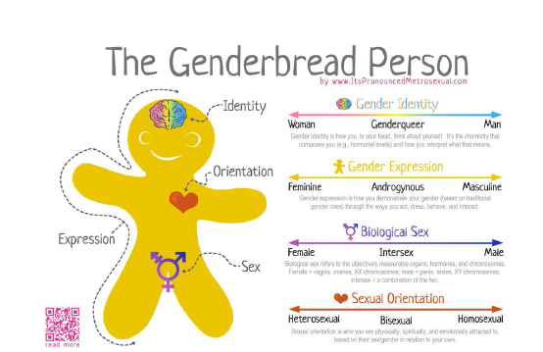
So when we work with integrating the polarities of masculinity and femininity, each person will have their own integration, and it will change with time. Our sexualities and our gender identities, expression—which are different—are fluid amalgams, which shift through the life cycle in complex ways.

So let’s not push clients to deny parts of themselves (engaging in a conspiracy of silence and conformity about gender expression possibilities and sexual desire possibilities).

Let’s provide ideal figures affirm all of who they are. And let’s allow them to have the affirming figures be whatever gender they wish/need, played by persons of whatever gender the client chooses!

Integrating the polarities of our existence include power, aggression, output on the one hand, and receptivity, taking in, input on the other. And masculinity and femininity. Recognizing this can help us see that rather than insisting on a male/female bifurcation, we can work, more helpfully, with the notion of a shifting continuum, a spectrum, a rainbow.

Compulsory heterosexuality, or heteronormativity, does a kind of violence to a significant group of human beings. Historically, invisibility has been the price of tolerance and survival. This blatantly or subtly enforced rule of invisibility means each child who is not cisgender and 100% heterosexual grows up thinking “I’m the only one.” And ‘there’s no place for me.” And we all know having a place is a basic human need.

In being a PBSP trainer around the world, my experience is that when I let the trainees know I’m gay, certain people are profoundly appreciative. They come up to me in the breaks and say things like “I’m lesbian.” If we spend enough time together, they let me know “My brother was gay and died of AIDS. I haven’t mentioned it to the group.” “I’ve had relationships with men and women,” “Thank you for helping create an expanded possibility sphere for me.”

But what about that you, the reader, may not be LGBTQ? Perhaps you can mention to your clients, your trainees, your colleagues that your mother was lesbian, or your daughter. Something that signals to the oppressed, ‘I am with you, you are safe here’.

In the Prague workshop I asked participants to divide into groups of three or four
and have a person enroll as “ideal parent.” I gave the following instructions:

“Enroll people in a way that stretches you a bit… that helps heal the wounds you uncovered in the previous exercise (I had asked them to find a part of themselves that wasn’t affirmed or was suppressed by their upbringing). For instance, have two males, or two females playing ideal parents, or ‘feminine aspects of their ideal father’ or ‘masculine aspects of their ideal mother’. Have them make statements you would have liked to have received, e.g.,“If I had been your ideal parent back then, I would have allowed you to play with dolls…”
Each get a turn. Then debrief. Then some sharing with the workshop.”

The exercise was well received; many felt it allowed them space to grow.

So my final message was this—affirmatively create a more open and welcoming possibility sphere for yourself and your clients. Ask what pronouns they use, what persons they want to play ideal parents, what parts of them need blessing.

Notes and further thoughts:

1. 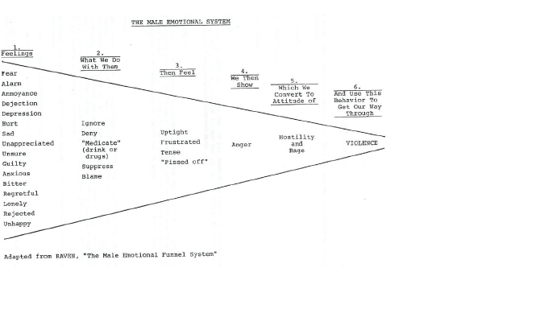

2. Think how John F. Kennedy and Lyndon Johnson, who each had empathic, sensitive sides, were determined to be seen as powerful (toxic masculinity) so they got the U.S. into and kept us in the Vietnam War, which cost over a million people their lives before it was ‘lost.’ And President Trump insisting to governors they must ‘dominate’ protestors. Men’s refusal to be vulnerable, to share, addiction to control cost millions of lives and create misery.

3.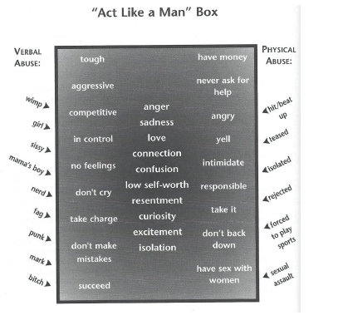

4. I am not the first to recognize this problem with PBSP and our society. As early as 1994 Gerrit de Bruine, a Dutch PBSP therapist, pointed out the problematic nature of seeing power as masculine and receptivity as feminine (Proceedings of the Second International Conference) and referred to Louis Sommeling and Liesbeth de Boer’s critiques of those connections in the Dutch Pesso bulletin in 1992. Louisa Howe, world-renowned sociologist and PBSP trainer, also spoke at the 1994 Second International conference in Atlanta of her dissatisfaction with that formulation. De Bruine said “By disconnecting the function from the biological difference we can create a possibility sphere in which both mothers and fathers can express their two sides through modeling. (p.83) And further, “It is not possible to determine in advance whether a child will have an imbalanced development if it grows up with one parent or with for instance a lesbian couple.” (p.84) De Bruine said then that he preferred the terms power or expressive capacity and openness or receptive capacity.

5. I have not been silent on these issues. At the first international Psychomotor conference in 1992 I spoke of “What PSP can learn from feminism”. At the second, which we hosted in Atlanta in 1994, I put together a panel: “Creating a Place for Sexual Orientation in PBSP”. By then I had learned Silence is not neutrality.

6. When a child ‘comes out of the closet’, the parent and family members ‘go in the closet’, meaning they begin the long journey from denial to acceptance, sharing and celebration of this aspect of their loved one. In helping the client and the family members, ‘neutrality’, a historic psychoanalytic ideal for therapists, serves to reinforce a life-threatening status quo. PBSP therapists can become facilitators of these journeys, helping all affirm and bless all of who each of us is. To do so we must educate ourselves. This is not an utter departure in PBSP—Diane Boyden Pesso was always clear that Psychomotor realizations were not just for structures, but were for healthy child rearing, personal relationships and social institutions. Diane taught positive parenting using psychomotor principles.

7. Speaking of blessing, I belong to an LGBTQ-founded synagogue, Congregation Bet Haverim (House of Friends). We started back when we weren’t welcome in traditional synagogues. At CBH we end each service with this “Prayer for the End of Hiding”:

(all who feel willing recite together)
As gay, lesbian, transgender, and queer Jews, we are aware of the loss of integrity suffered due to pressures of the larger society. We often feel forced into a dishonest presentation of ourselves, to ourselves and others.
The LGBTQ individuals who feel they must pretend to be something that they are not, the Jews who feel they must be alienated from their tradition and community to gain larger acceptance, both are victims of the theft of identity and integrity committed by the sexual or religious majority.
Creator of the universe, we ask that our hiding be brought to an end, that we no longer feel we have to pretend, to promise falsely, to renounce ourselves, and that our fullest creative expression as Jews and as gay, lesbian, transgender, and queer be among the blessings you bestow upon us. Amen.

References:

DeAngelis, Tori “Our Erotic Personalities Are as Unique as Our Fingerprints,” APA Monitor, April 2001.

De Bruine, Gerrit. “Power and Vulnerability: Redefinition and Implications for Gender Issues in Pesso Psychotherapy,” Proceedings of the Second International Conference on Pesso-Boyden System Psychomotor Therapy, Carl T. Clarke, Ph.D. & R. Mott, Ph.D., Eds. Atlanta: Southeastern Psychomotor Society, 1996.

Faludi, Susan The Terror Dream: Myth and Misogyny in an Insecure America, Picador, 2007.

Frye, Marilyn. The Politics of Reality: Essays in Feminist Theory, Crossing Press, 1983.

Kaufman, Gus "Creating a Place for Sexual Orientation in PBSP," Proceedings of the Second International Conference on Pesso-Boyden System Psychomotor Therapy, Carl T. Clarke, Ph.D. & R. Mott, Ph.D., Eds. Atlanta: Southeastern Psychomotor Society, 1996.

Kaufman, Gus. "What PS/P Can Learn from Feminism," Pesso Bulletin (Official organ of the Vereniging voor Pesso Psychotherapie) Eelde, Netherlands, Fall, 1992.

Kivel, Paul. Boys Will Be Men: Raising Our Sons for Courage, Caring and Community, New Society Publishers, 1999.

Real, Terrence. I Don’t Want to Talk About It: Uncovering the Secret Legacy of Male Depression, Scribner, 1998.

Rich, Adrienne. Blood, Bread and Poetry: Selected Prose 1979-1985. W.W. Norton, 1986.

Gus Kaufman, Ph.D. is a psychologist, social activist and senior PBSP trainer, having been certified in 1976. His doctoral dissertation Body Signals of Childhood Loss was a theoretical and experimental validation of key PBSP concepts, later summarized in a chapter in Moving Psychotherapy. Gus has conducted PBSP training around the U.S. and Europe and has presented at all of the international PBSP conferences.

